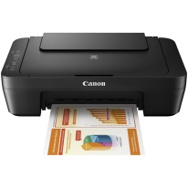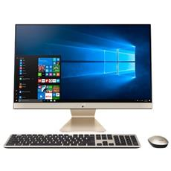

PC “ASUS” ALL IN ONE

+

STAMPANTE MULTIFUNZIONE “CANON”

+

CASSA AUDIO SPEAKER “BOSE”

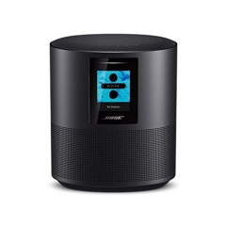

680,00€

**anziché**

~~850,00€~~

650,00€